**Solution for Problem4 of Module 2 Assignment**

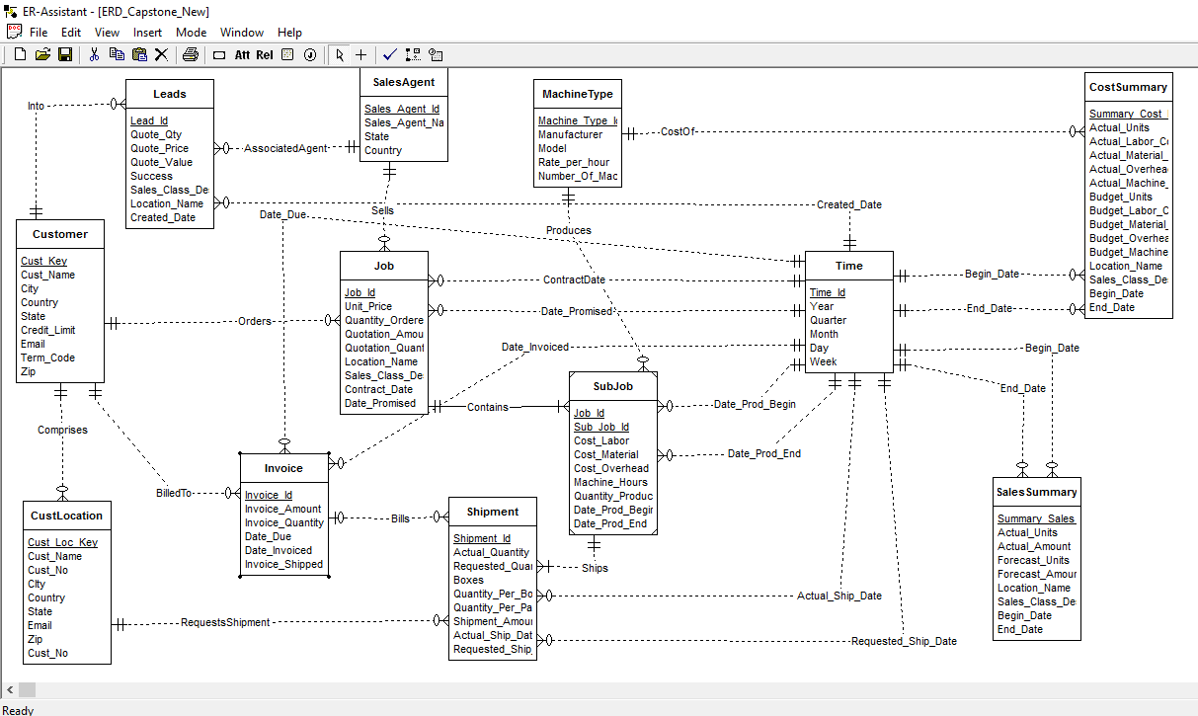

ERD diagram above shows the different fact and dimension tables.

Dimension Tables are: (Only Primary Key is Marked,Other details in the diagram)(Five)

1. **Customer**

Cust_Key(PrimaryKey)

1. **CustLocation**

Cust_Loc_Key(Primary Key)

Cust_No(Keeps Count when same customer in different location)

1. **SalesAgent**

Sales_Agent_Id(Primary Key)

1. **MachineType**

Machine_Type_Id(Primary Key)

1. T**ime**

Time_Id(Primary Key)

Fact Tables are: (Only Primary Key is Marked,Other Details in the diagram)

1. **Job**

Job_Id(Primary Key)

Instead of Location_id, Location_Name is used in the table directly.

Instead of Sales_Class_id, Sales_Class_Desc is used in the table directly.

1. **SubJob**

(Job_Id,Subjob_Id)- Primary Key

1. **Shipment**

Shipment_Id(Primary Key) Instead of Sales_Class_id, Sales_Class_Desc is used in the table directly.

1. **Invoice**

Invoice_Id(Primary Key)

1. **CostSummary**

Summary_Cost_Id(Primary Key)

Instead of Location_id, Location_Name is used in the table directly.

Instead of Sales_Class_id, Sales_Class_Desc is used in the table directly.

1. **SalesSummary**

Summary_Sales_Id(Primary Key)

Instead of Location_id, Location_Name is used in the table directly.

Instead of Sales_Class_id, Sales_Class_Desc is used in the table directly.

1. **Leads**

Lead_Id(Primary Key)

Instead of Location_id, Location_Name is used in the table directly.

Instead of Sales_Class_id, Sales_Class_Desc is used in the table directly.

**Showing different fact tables:**

|  |  |  |  |
| --- | --- | --- | --- |
| **Schema type** | **Dimension tables** | **Fact table** | **Comments** |
| Shipment Star Schema | CustLocation,  Time(Actual_Ship_Date)  Time(Requested_Ship_Date) | Shipment | Shipment keep tracks of shipped products. |
| Job Star Schema | Customer,  Time(Contract_Date)  Time(Date_Promised)  SalesAgent | Job | This keeps track of the different jobs added to the databases. |
| SubJob Star Schema | Customer  MachineType,  Time(Date_Prod_Begin)  Time(Date_Prod_End) | SubJob | This maintains a list of subjobs for each job. |
| Invoice Star Schema | Customer,  Time(Date_due)  Time(Date_Invoiced) | Invoice | This maintains the invoice generated for each item bought by customer or shipped. |
| Cost(Summary) Schema | Time(Begin_Date)  Time(End_Date),MachineType | Cost(Summary) | This maintains the cost data for different things. |
| Sales(Summary) Schema | Time(Begin_Date)  Time(End_Date) | Sales(Summary) | This maintains the sales data for different tables. |
| Leads Schema | Customer  Time(Created_Date)  Sales_Agent | Leads | This maintains the data about different leads. |